Muhammad Irfan
English Composition 10100
Prof Anna Voisard
May 23, 2022
Is Water Pollution Real
Water pollution is supposed to be one of the biggest issues going around the world right now, but is it real? Does water pollution really exist? Or is it something that is just created and has nothing to worry about? The answer to this question varies for different people. Most people think water pollution is indeed a major issue to be concerned about, but some think it is nothing and there is no need to focus on it. Before answering that question, what water pollution actually is? Water pollution is the contamination of water bodies, usually as a result of human activities, but it can also occur naturally. Water pollution results when contaminants are introduced into these water bodies. Water pollution degrades the quality of water.
Water pollution is the addition of pollutants in water bodies like lakes, rivers, and oceans. Water pollutants are substances that are introduced into the water and have undesirable effects on the water, aquatic life, and living organisms using that water for their daily needs. There are different water pollutants like inorganic materials, organic materials, and pathogens. The pathogenic organisms are the most serious water pollutants in terms of human health. One-third of all the waterways in Pennsylvania are polluted and are harmful to wildlife, recreation, or drinking (“Kummer”).
There are many causes of water pollution that include both natural, and human activities. Naturally, water pollution can be done by volcanic eruptions, animal waste, floods, and algae. Water pollution done by human activities includes things like runoffs, sewage, mining, transportation, construction, landfills leakage, accidental leaks, and oil spills. Activities like Volcanic eruption adds toxic pollutants like fluorine and metals like arsenic and cadmium into nearby water and then those pollutants are carried away into rivers and oceans by the flow of water. Waste of animals in the forests and on farms does not get all handled and disposed of properly and it also ends up being in the water. That animal waste, like cow manure, contains phosphorus and nitrogen (“Why are Cows Bad for Environment”).
Sewage released into the water is one of the biggest causes of water pollution done by human activities. If sewage is not treated properly then it releases harmful chemicals into the waterways and also is a major cause of the presence of pathogenic organisms in the water. These pathogenic organisms are the most serious water pollutants in terms of human health as they are the root of many water-related diseases. Each year, approximately 3.6 million people die as a result of those water-related diseases. 20% of those mortalities are of children under the age of five (“Water Pollution, Deirdre”). These diseases are transmitted by using contaminated water for purposes like drinking, sanitation, and others. Those diseases also spread when we consume food that was produced using water from a contaminated site (Abel 67). Less developed or developing countries has this issue of releasing untreated sewage water into nearby waterways greater than developed countries.
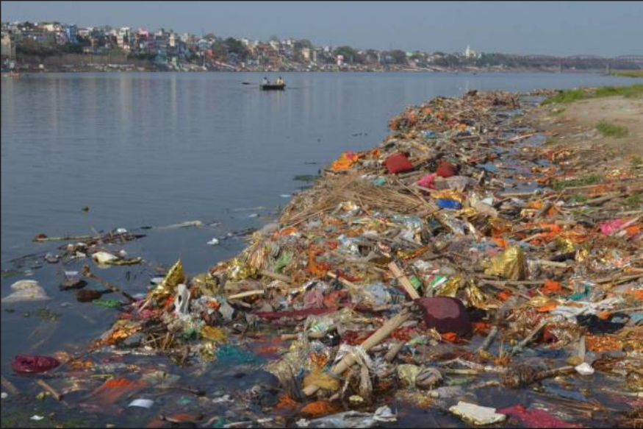
I was born in Pakistan and lived there for 15 years of my life. It is a developing country, and the water condition is very bad there. There are not many water treatment plants there so most of the sewage goes directly into the waterways like canals and ends up in rivers and oceans. Even the sewage treatment plants do not work properly and leave most of the pollutants in the treated water and release that into rivers. The image above is of a river in Pakistan. This is how people throw away their garbage into rivers and there are no rules to punish those people. According to an estimation, nearly 400 million gallons of untreated sewage and sanitation waste were being dumped into the sea on daily basis and it also posed a serious threat to aquatic life (The News, 2020). Other than domestic sewage, industrial sewage contains much more toxic and hazardous substances. Industries also use 20% of fresh water on earth and thus produce an enormous amount of sewage that also ends up in rivers and oceans. An analysis published in 2020 by the watchdog group the Environmental Working Group (EWG) warned that the contamination of US drinking water with perfluoroalkyl substances (PFAS) was much worse than it had previously estimated. PFAS are chemicals that do not break down in the environment and are associated with diseases like cancer, liver damage, and low birth rate. As of May 2020, nearly 1,600 locations in 49 states of the US are known to have PFAS (“Water Pollution”). Using the US as an example, the main industrial consumers of water (using over 60% of the total consumption) are power plants, petroleum refineries, iron, and steel mills, pulp and paper mills, and food processing industries. Some industries discharge chemical wastes, including solvents and heavy metals (which are toxic), and other harmful pollutants. Although that water goes through many treatment processes, still some pollutants such as lead, mercury, and other heavy metals are left behind and cause contamination of water.
Water pollution is worse in developing countries because of the lack of technology and money. Other than sewage, another major issue in developing countries is fertilizers. The fertilizers used in those countries are not prepared well and contain many toxic substances like methane. In case of strong winds or floods, those substances make their way into the water and cause water pollution. Due to the intake of drinking water from contaminated groundwater sources, millions of people in Bangladesh are suffering from acute and chronic arsenic poisoning. The increased levels of arsenic in shallow aquifer waters are naturally occurring and have most likely been present for thousands of years. However, arsenic isn't the only issue with Bangladesh's groundwater quality. Groundwater in various sections of the country is characterized by high amounts of dissolved iron, manganese, and boron. Furthermore, dissolved uranium concentrations appear to be a water-quality issue in some regions; but, due to a lack of data, the nature and scope of the problem remain unclear. Furthermore, climate change and rising sea levels are expected to increase salt in the country's coastal groundwater systems. As a result, one of the greatest environmental challenges in this mostly rural country is access to safe drinking water.
Water pollution is a much worse problem than it seems to be. Water contamination has been linked to a number of health issues in children. The children that are harmed have both long-term and short-term consequences. We must be aware of these health dangers in order to grasp the consequences of our actions while exposing our children to such pollution. Diarrhea, amoebiasis or cholera, typhoid, respiratory infections, and vomiting are some of the acute effects. It may also create skin problems in the youngster. The long-term health consequences of this could include slowed growth and a variety of developmental difficulties, including learning and behavioral disabilities. DNA damage, liver and kidney damage, and nervous system damage are all possibilities. This is because contaminated drinking or bathing water contains hazardous compounds or microbes. Children that drink contaminated water will be exposed to the damaging effects of the toxins on their growing organs and tissues, resulting in long-term damage. When compared to adults, children are more exposed to this. When opposed to adults, they are more susceptible due to their underdeveloped immune.
Water pollution is such a big issue but still many people believe there is nothing like water contamination just because the water they are drinking is safe. According to “Americans Don't Care That Much About the Environment, Poll Shows” by Alexandra Sifferlin, studies have shown that only 55% care about water pollution (“Kelvin, 2019”). Unfortunately, not everyone recognizes the significance of water pollution. Human greed can occasionally rule over reason and logic. Many businesses are concerned about saving money and hence disregard water. Nobody wants to lose money, which is why these businesses are willing to tamper with water in order to make more money. Oil firms are unconcerned about their impact on the environment. They actually wish to dispose of their garbage without losing money. Some people also don’t care about water pollution because they have access to clean water and they think that others have access to clean water too. The Clean Water Act is meant to regulate the discharge of these chemicals into the nation's lakes, rivers, streams, wetlands, and coastal areas. But the Trump administration has been loosening pollution regulations over the past 3.5 years (“Sarda, 2020”). Another reason for people to not believe in water pollution is illiteracy, especially in developing countries because most of the people there are not educated properly about this issue.
Although some people do not believe in water pollution, it is still there and is impacting the health of millions of people daily. People are becoming ill and dying because of the contamination of water. Water pollution is a major issue that is impacting many and will impact all in near future, if not resolved now. We need to save water and use as much sustainable energy as we can.

Work Cited
“400m Gallons of Untreated Sewage Being Dumped into Sea.” Thenews, The News International, 27 Jan. 2020, https://www.thenews.com.pk/print/604909-400m-gallons-of-untreated-sewage-being-dumped-into-sea.
Kevin, L. “Pollution Isn't Real?” Pollution Isn't Real? - American Creed, 26 Feb. 2019, https://writingourfuture.nwp.org/americancreed/responses/1406-pollution-isn-t-real.
Kummer, Frank. "Nearly 28,000 miles of Pennsylvania's streams are impaired by pollution, report finds." Philadelphia Inquirer [Philadelphia, PA], 20 Jan. 2022, p. NA. Gale In Context: Opposing Viewpoints, link.gale.com/apps/doc/A689935645/OVIC?u=cuny_ccny&sid=bookmark-OVIC&xid=bc9d73ac. Accessed 30 Mar. 2022.
Sarda, Bruno. “Companies Blind to Risks of Water Pollution and Scarcity, and the Untapped Opportunity to Address It.” Greenbiz, 11 May 2020, https://www.greenbiz.com/article/companies-blind-risks-water-pollution-and-scarcity-and-untapped-opportunity-address-it.
"Water pollution." Environmental Encyclopedia, edited by Deirdre S. Blanchfield, Gale, 2011. Gale In Context: Opposing Viewpoints, link.gale.com/apps/doc/CV2644151471/OVIC?u=cuny_ccny&sid=bookmark-OVIC&xid=8547e766. Accessed 23 May 2022.
"Water Pollution." Gale Opposing Viewpoints Online Collection, Gale, 2020. Gale In Context: Opposing Viewpoints, link.gale.com/apps/doc/PC3010999330/OVIC?u=cuny_ccny&sid=bookmark-OVIC&xid=5745ac19. Accessed 30 Mar. 2022.

“WHY ARE COWS BAD FOR THE ENVIRONMENT AND WHAT CAN YOU DO?” Thehumaneleague.org, 9 Nov. 2021, https://thehumaneleague.org/article/why-are-cows-bad-for-the-environment.

